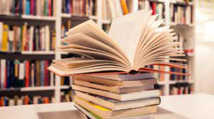
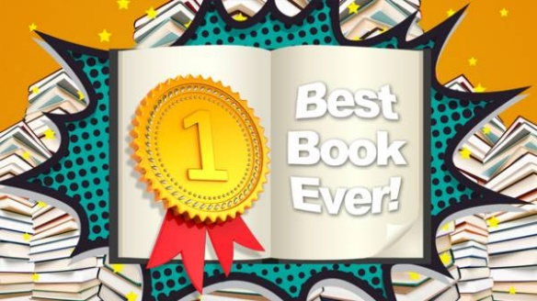
Book review…
Name:

Primary School:

What is your favourite book?

Star rating:

What is the book about?

Who are the main characters?

Why is it your favourite book?

