**Vegetable Lasagne**: Making the cheese sauce

|  |  |  |  |  |
| --- | --- | --- | --- | --- |
| http://www.britishcornershop.co.uk/images/large/QWOP2151.jpg | **http://www.healingdaily.com/detoxification-diet/essential-fatty-acids-not-margarine.jpg** | http://www.freedigitalphotos.net/image/s_grated-cheese1.jpg | http://cache1.asset-cache.net/xt/56399750.jpg?v=1&g=fs1%7C0%7CPDI%7C99%7C750&s=1 | http://affordableorganics.com.au/wp-content/uploads/lasagne-sheets.jpg |
| **50g**  Plain Flour | **50g** Margarine | **150g** Cheese | **500ml** Milk | Lasagne sheets |

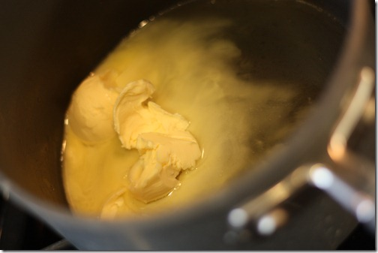

1. Melt the **margarine** in a

saucepan on a low heat

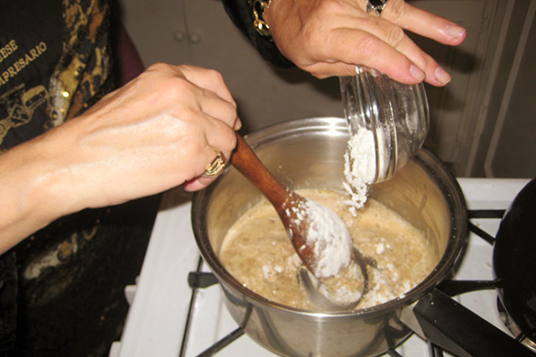

2. Stir in the **flour** and

cook for 1 min

[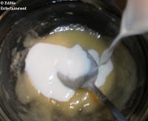](http://3.bp.blogspot.com/-BFkbMnUFGd4/Tt2Dj9TK3nI/AAAAAAAACPM/LjTwOyLmohU/s1600/Cheese+Sauce+(in+microwave)06.JPG)

3. Gradually stir in the **milk** to

make a thick white sauce.

[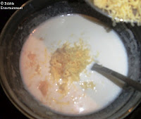](http://2.bp.blogspot.com/--6_QjjCpUT4/Tt2DkvToQbI/AAAAAAAACPQ/Xd-pwV9EHd0/s1600/Cheese+Sauce+(in+microwave)07.JPG)

4. Take from the heat and stir

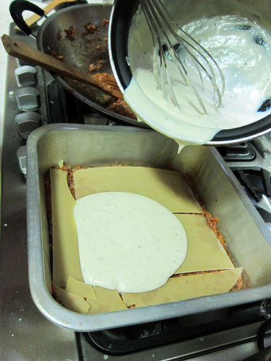in half of the **cheese**.

5. Pour the sauce on top of each lasagne sheet before adding another layer of the vegetables.Sprinkle top with cheese and put in the oven for 30 mins.

**Vegetable Lasagne**: Preparing the ingredients

|  |  |  |  |  |  |
| --- | --- | --- | --- | --- | --- |
| http://img.tesco.com/Groceries/pi/431/5000436541431/IDShot_225x225.jpg | http://www.buonissimo.org/archive/borg/JqPMAJqI4%252BVlwrEDFIKyXCfBm65COuzzfGpf29%252F2SfU4srqzJ6%252BsFA%253D%253D | http://www.camerican.com/files/8812/8556/9526/iStock_000012105607XSmall.jpg | [http://www.bigoven.com/uploads/greenbellpepper.jpg](http://www.google.co.uk/url?sa=i&source=images&cd=&cad=rja&uact=8&ved=0CAgQjRw&url=http://www.bigoven.com/article/recipe/green-bell-pepper&ei=S0BCVIv2OeOu7AbG34CIDA&psig=AFQjCNHzHXuQyP2A-PdGI1xT6-7DnmYXxQ&ust=1413714380026303) | http://cdn3.volusion.com/gyauc.spxen/v/vspfiles/photos/REDONION200-2.jpg?1342260329 | http://www.scobiesdirect.com/scobiesdirectimages/MainPictures/AS22058301.jpg |
| **Tin of Tomatoes** | **Courgettes** | **Mushrooms** | **Peppers** | **Red Onion** | **Foil Tray** |

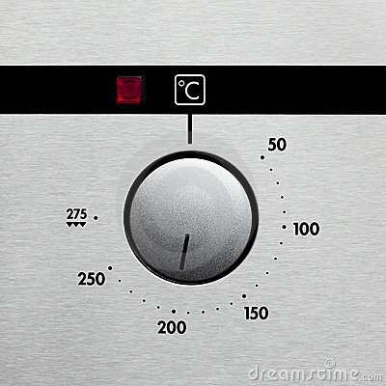

1. Heat oven to **180C**.



2. Chop the **courgettes**, **mushrooms**, **peppers** and **onions** and put in a saucepan.

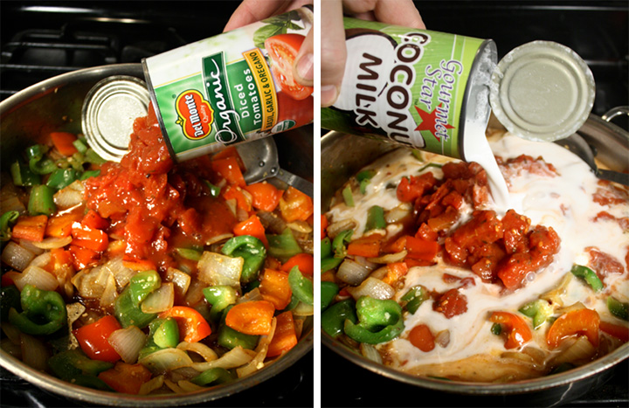

3. Add the **tin of tomatoes** to the saucepan and simmer for about **15 minutes**.

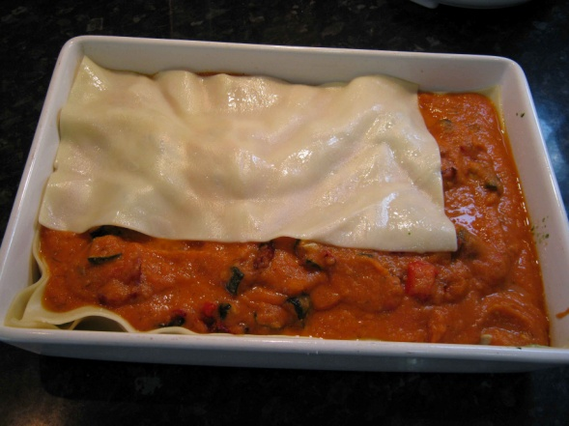4. Put a layer of cooked vegetables in the bottom of the foil tray and cover with the lasagne sheets.

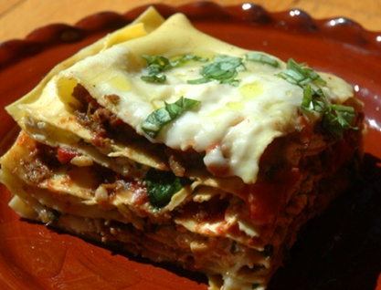

5. Pour the sauce on top of the lasagne sheet before adding another layer of the vegetables.(*Repeat until the tray is full)*